WIA/WIB 2003 – Probability and Statistics
Bayes Theorem

- Marie is getting married tomorrow, at an outdoor ceremony in the desert. In recent years, it has rained only 5 days each year. Unfortunately, the weatherman has predicted rain for tomorrow. When it actually rains, the weatherman correctly forecasts rain 90% of the time. When it doesn't rain, he incorrectly forecasts rain 10% of the time. What is the probability that it will rain on the day of Marie's wedding?
- In a particular pain clinic, 10% of patients are prescribed pain killers. Overall, five percent of the clinic’s patients are addicted to narcotics (including pain killers and illegal substances). Among the addicts in the clinic, 8% have been prescribed narcotics. If a patient is prescribed pain pills, what is the probability that they will become an addict?

- An unknown marine fossil fragment was found at the fossil site in a stream bed. You want a better fossil, but there are two possible sources up stream. Drainage basin B1 covers 180 km² and B2 covers 100 km²

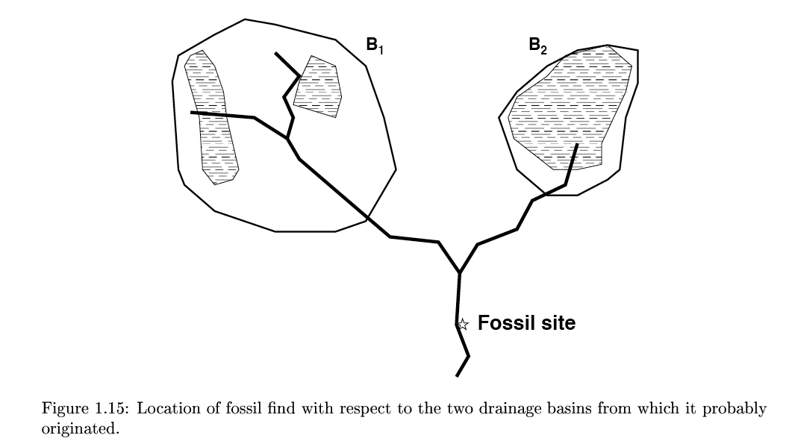
Based on the area alone, the probability that the fossil comes from one or the other basins is:
P(B1)=180/280=0.64
P(B2)=100/280=.36
However, a geological map shows that 35% of the outcrops in B1 are marine, while 80% of the outcrops in B2 are marine. The conditional probabilities are:
P(A|B1)=0.35 probability of fossil given B1
P(A|B2)=0.80 probability of fossil given B2
Find the probability that the fossil came from B1, given that the fossil is marine:

- While watching a game of football in a cafe, you observe someone who is clearly supporting Manchester United in the game.
What is the probability that they were actually born within 25 miles of Manchester? Assume that:
• the probability that a randomly selected person is born within 25 miles of Manchester is 1/20;
• the chance that a person born within 25 miles of Manchester actually supports United is 7/10;
• the probability that a person not born within 25 miles of Manchester supports United with probability 1/10

THE END

